Day 5 Assemble and Disassemble
1:- List all the main components you find inside a desktop PC after opening the cabinet, and write a short description (1-2 lines) for each.
Main Components Inside a Desktop PC
After opening a desktop PC cabinet, the following main components can be found:
No. | Component | Description
1 | Motherboard | The main circuit board of the computer. It connects all major components such as the CPU, RAM, storage, and power supply.
2 | CPU (Processor) | The main processing unit of the computer. It performs calculations and executes instructions to run programs.
3 | CPU Cooler (Fan + Heatsink) | Keeps the CPU cool by absorbing heat through the heatsink and moving air over it using the fan.
4 | RAM (Random Access Memory) | Temporary memory used by the computer to store data and programs that are currently in use.
5 | HDD/SSD (Storage Drive) | Stores the operating system, software, documents, photos, and other files permanently.
6 | Power Supply Unit (PSU) | Provides electrical power to the motherboard, CPU, storage drives, fans, and other components.
7 | GPU (Graphics Processing Unit) | Processes images, videos, and graphics and sends the visual output to the monitor. It can be integrated or dedicated.
8 | Cooling Fans | Circulate air inside the cabinet to remove hot air and maintain proper temperature.
9 | SATA Cables | Connect SATA storage drives such as HDDs and SSDs to the motherboard for data transfer.
10 | CMOS Battery | A small battery on the motherboard that maintains the system clock and helps retain BIOS settings when the computer is turned off.

2:- Take clear photos or draw labeled diagrams of each step as you disassemble a desktop PC, and organize them in a document with captions explaining what you did at each step.<br><br><em><strong>Hint:</strong> Include steps like unplugging power, removing side panel, disconnecting cables, and removing RAM, HDD/SSD, and motherboard.</em>

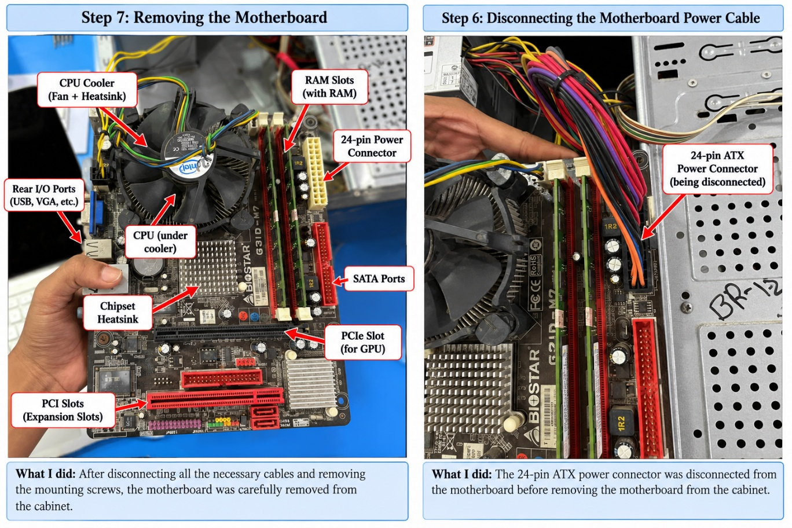

3:- Reassemble the PC you disassembled, documenting each step with a brief explanation of what you connected or installed and why the order matters.
Reassembly of the Desktop PC
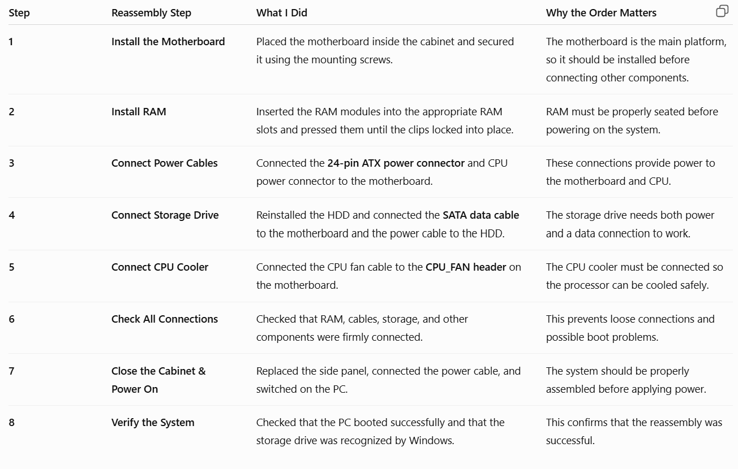
4:- Create a checklist of safety precautions and tools needed before starting the PC assembly/disassembly process, and explain why each is important.

A. Safety Precautions
No. | Safety Precaution | Why It Is Important
1 | Switch off and unplug the PC | Prevents electric shock and protects the components from electrical damage.
2 | Disconnect all external cables | Prevents accidental pulling or damage to cables and connectors.
3 | Use an anti-static wrist strap | Protects sensitive components from static electricity (ESD).
4 | Work on a clean, dry surface | Prevents dust, moisture, and small objects from damaging the components.
5 | Handle components by their edges | Prevents touching and damaging sensitive circuits and connector pins.
6 | Do not force connectors or components | Prevents damage to ports, pins, RAM slots, and other parts.
7 | Keep screws organized | Prevents losing screws and helps ensure the correct screws are used during reassembly.
8 | Take photos before disconnecting cables | Helps remember the correct cable positions during reassembly.
B. Tools Required
No. | Tool | Purpose
1 | Phillips-head screwdriver | Used to remove and tighten most PC screws.
2 | Anti-static wrist strap | Prevents static electricity from damaging electronic components.
3 | Small container/magnetic tray | Keeps screws and small parts organized.
4 | Soft brush or compressed air | Used to remove dust from fans, heatsinks, and other components.
5 | Cable ties | Used to organize cables and improve airflow inside the cabinet.
6 | Torch/flashlight | Helps see small connectors and components inside the cabinet.
Conclusion
Before starting PC assembly or disassembly, the computer should be completely powered off and unplugged. Using proper tools, preventing static electricity, handling components carefully, and keeping screws and cables organized helps prevent damage and makes the process safer and easier.

